- FIREWALL, NAT AND PACKET FILTERING ASSIGNMENT
Q1. Block Incoming Traffic on Port 8080 Using Windows Defender Firewall
Objective: Create an inbound firewall rule that blocks incoming TCP traffic on port 8080.
Steps:
- Press Windows + R, type wf.msc, and press Enter. This opens Windows Defender Firewall with Advanced Security.
- Click Inbound Rules on the left side.
- Click New Rule... on the right side.
- Select Port and click Next.
- Select TCP and choose Specific local ports.
- Enter 8080 and click Next.
- Select Block the connection and click Next.
- Keep Domain, Private, and Public selected, then click Next.
- Enter the rule name: Block Port 8080.
- Click Finish. The new inbound rule will appear in the Inbound Rules list.
Result: Incoming TCP connections directed to local port 8080 are blocked by Windows Defender Firewall.
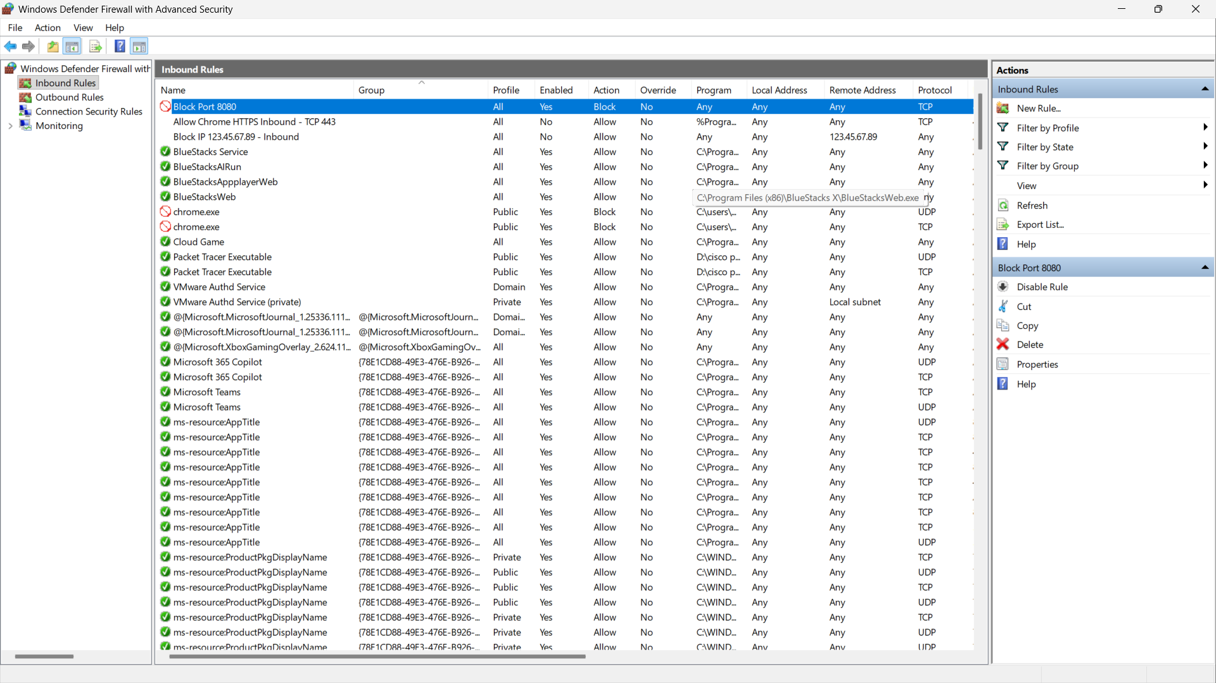
Q2. NAT (Network Address Translation) Simulation
NAT allows devices using private IP addresses inside a home network to access the Internet through a single public IP address. The Wi-Fi router changes the private source address to its public address when traffic goes to the Internet and keeps track of the connection.
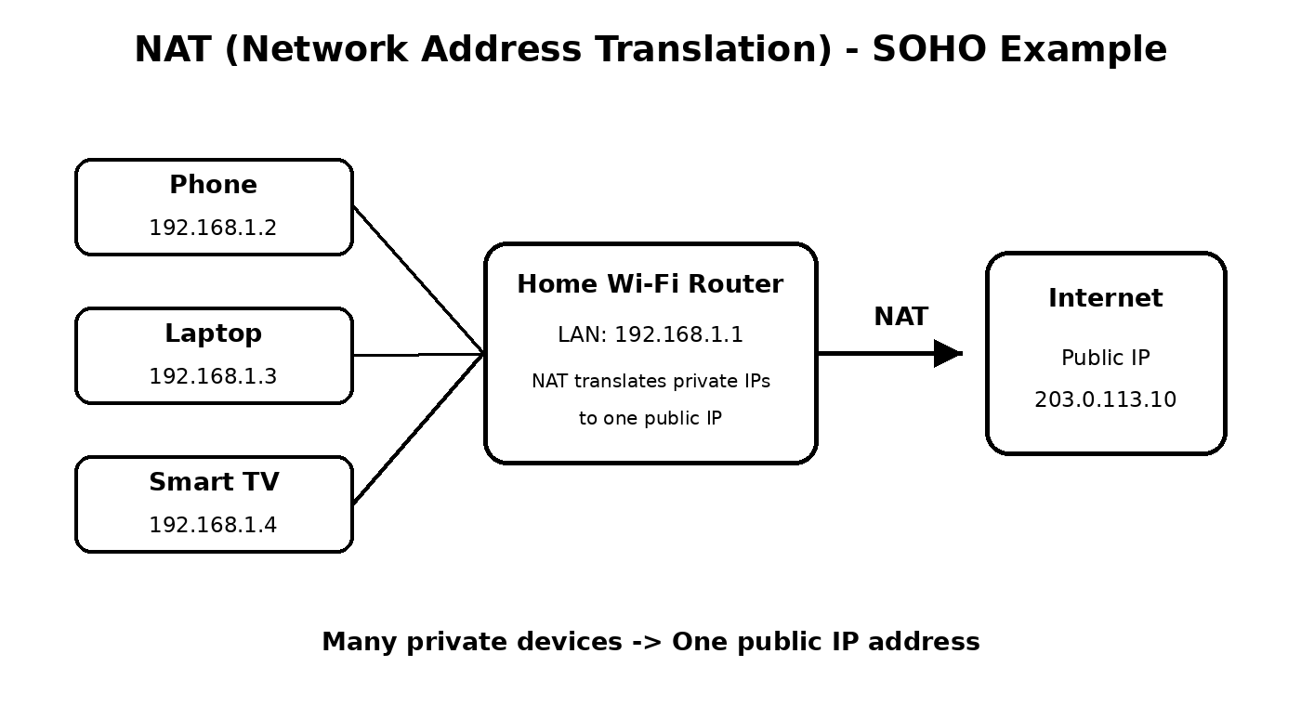
- Phone private IP: 192.168.1.2
- Laptop private IP: 192.168.1.3
- Smart TV private IP: 192.168.1.4
- Router LAN IP: 192.168.1.1
- Example public IP used in the diagram: 203.0.113.10 (documentation/example address)
Explanation: When the phone, laptop, or Smart TV sends data to the Internet, the router performs NAT. To Internet servers, the traffic appears to come from the router's public IP rather than directly from the private 192.168.1.x addresses.
Q3. Block Outgoing Port 25 (SMTP) Using Port Filtering
Since a physical Wi-Fi router is not available, this task can be demonstrated using a router simulator or a router interface that provides outbound/port filtering.
General simulator/router steps:
- Open the router simulator or router administration page.
- Open Firewall, Access Control, Security, or Port Filtering settings. The exact menu name depends on the router.
- Create a new outbound filtering rule.
- Select TCP as the protocol.
- Set the destination/service port to 25 (SMTP).
- Set the action to Deny or Block.
- Apply the rule to the required LAN devices, or to all LAN clients if the simulator allows it.
- Save/Apply the settings and confirm that the rule is enabled.
Why this can help prevent spam:
Blocking outgoing TCP port 25 can stop ordinary devices or malware on the local network from directly sending SMTP mail to external mail servers. This can reduce spam originating from compromised devices, although legitimate mail systems that require direct SMTP on port 25 would need an exception.
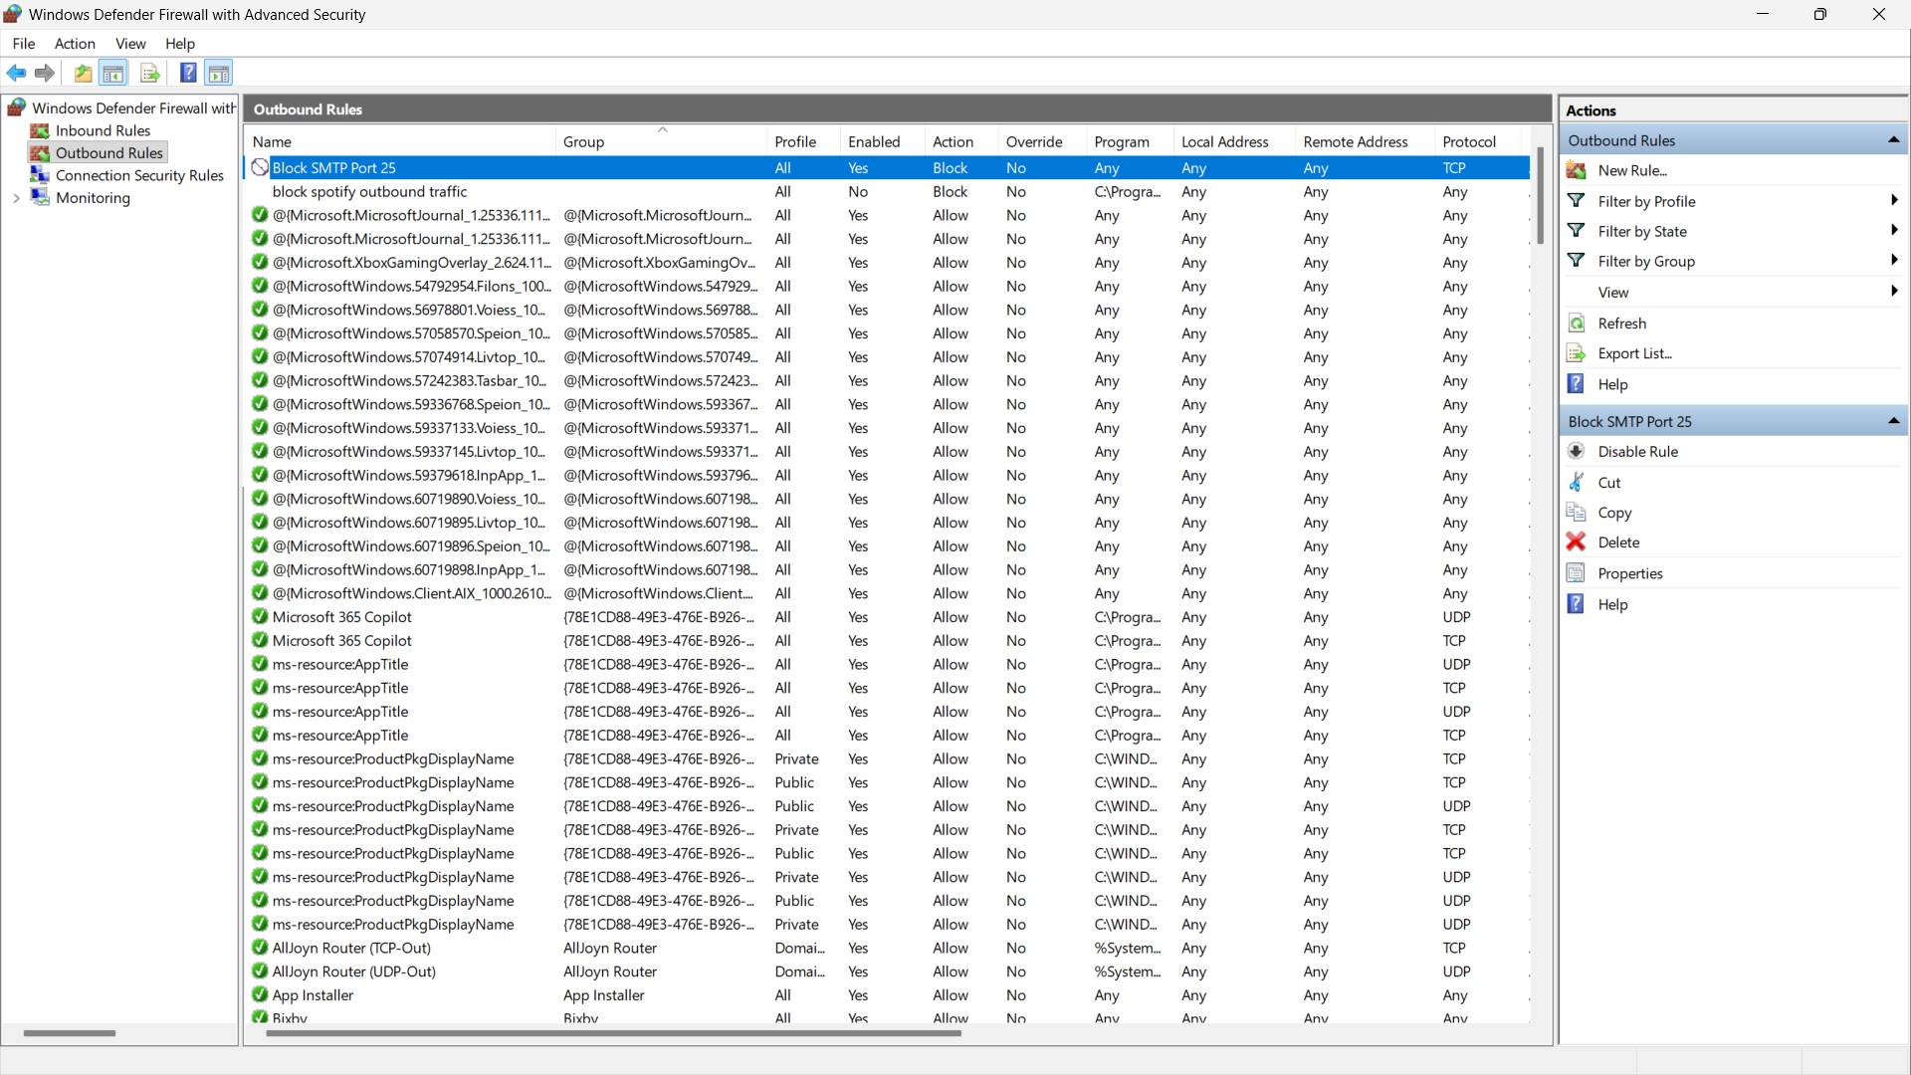
Q4. Identify Allowed and Blocked Packets
Note: The trainer's actual packet-filtering rule set was not included with this question. The table below is an example analysis using this sample rule set: allow HTTP (TCP 80) from 192.168.1.0/24, block SSH (TCP 22) from 10.0.0.0/24, and allow DNS (UDP 53) from 192.168.1.0/24. If the trainer provides different rules, the answers must be changed according to those rules.
Packet | Source | Destination | Port/Service | Result
1 | 192.168.1.5 | 172.217.166.78 | 80 / HTTP | Allowed
2 | 10.0.0.10 | 34.201.23.1 | 22 / SSH | Blocked
3 | 192.168.1.7 | 8.8.8.8 | 53 / DNS | Allowed
Reason:
- Packet 1 is allowed because it is HTTP traffic using destination port 80 from the permitted 192.168.1.0/24 network.
- Packet 2 is blocked because it is SSH traffic using destination port 22 from the 10.0.0.0/24 network, which the example rule blocks.
- Packet 3 is allowed because it is a DNS query using port 53 from the permitted 192.168.1.0/24 network.
Q5. Three Ways Instagram or Zomato Can Use Firewalls and Packet Filtering
Large online services such as Instagram or Zomato can use firewalls and packet filtering as part of several layers of security. Three simple examples are:
1. Allow Only Required Ports
A firewall can allow normal web traffic such as HTTPS on port 443 while blocking unnecessary ports. This reduces the number of network services that attackers can directly reach.
2. Block Suspicious or Malicious Traffic
Packet-filtering rules can block or limit traffic from suspicious IP addresses, unwanted network ranges, or abnormal connection patterns. This can help reduce scanning, automated abuse, and some attack traffic.
3. Separate Public Servers from Internal Systems
Firewalls can separate Internet-facing web servers from internal databases and administration systems. Only specifically required traffic is allowed between these network areas, which makes it harder for an attacker to move deeper into the network.
Conclusion
In this assignment, Windows Defender Firewall is used to demonstrate inbound port blocking, NAT is shown using a home network diagram, outbound SMTP filtering is demonstrated conceptually, and packet-filtering examples show how IP addresses, protocols, and port numbers are used to allow or block traffic.

